1. Produce a line plot showing multiple lines with proper labels and legend. Describe what conclusions you can draw from this plot.

**Data set:** <https://www.kaggle.com/code/alexisbcook/line-charts/data?select=spotify.csv>

**Description:**

The plot depicts the daily global streams of 5 songs on Spotify from 06-10-2017 to 09-01-2018. It can be seen that initially songs were in trend and then with the passage of time popularity decreased as daily streams began to decrease. “Despacito” was the most streamed song, “HUMBLE” was average streamed and

“Something just like this” was the least streamed song.

**Plot:**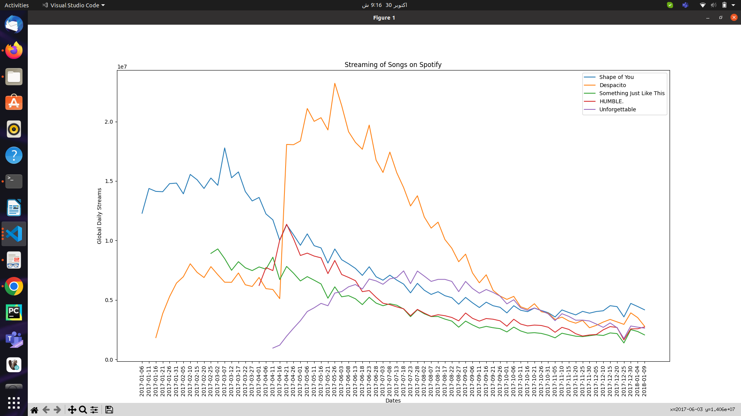

1. Produce graphs using two other visualisation methods. Explain why you picked this type of graph and describe what conclusions you can draw.

a)

**Data set:** <https://data.worldbank.org/indicator/NY.GDP.MKTP.KD.ZG>

**Description:**

The following plot depicts daily global streams of 5 songs Shape of You, Despacito, Something Just Like This, HUMBLE. And Unforgettable on Spotify on 2017-04-08.

Bar plot was picked because the data can be clearly visualized using bar plot where more the height of the bar more the growth and the growth of each country can also be easily compared with the others.

Plot depicts that among Shape of you was the most streamed whereas HUMBL. remained average whereas the least streamed song was unforgettable.

**Figure:**

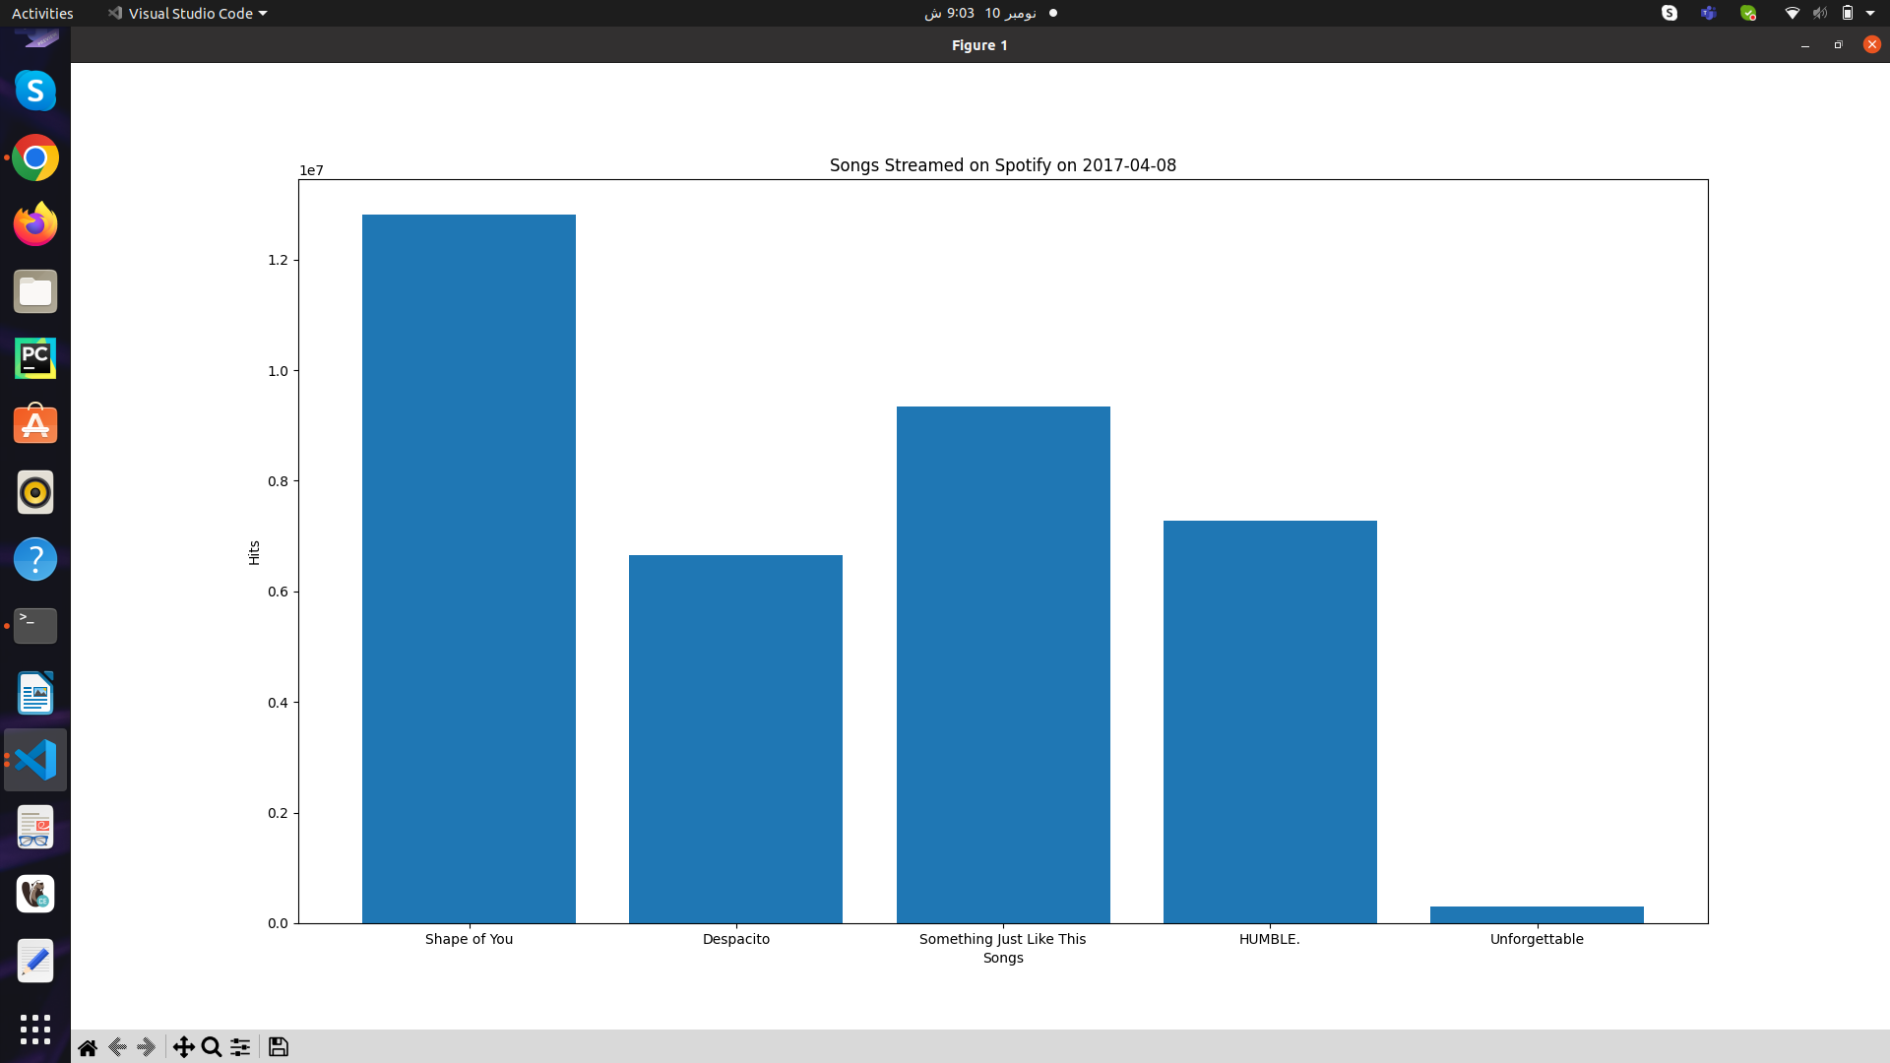

b)

**Data set:** <https://www.kaggle.com/code/alexisbcook/scatter-plots/data?select=insurance.csv>

**Description:**

The following plots depicts global streams of song Despacito on Spotify over the course of an year.

Scatter plot was picked because it can clearly help in visualizing the streaming pattern over an year.

The scatterplot portrays the number of streams increased gradually untill it reached its max and then the number started declining.

**Figure:**

